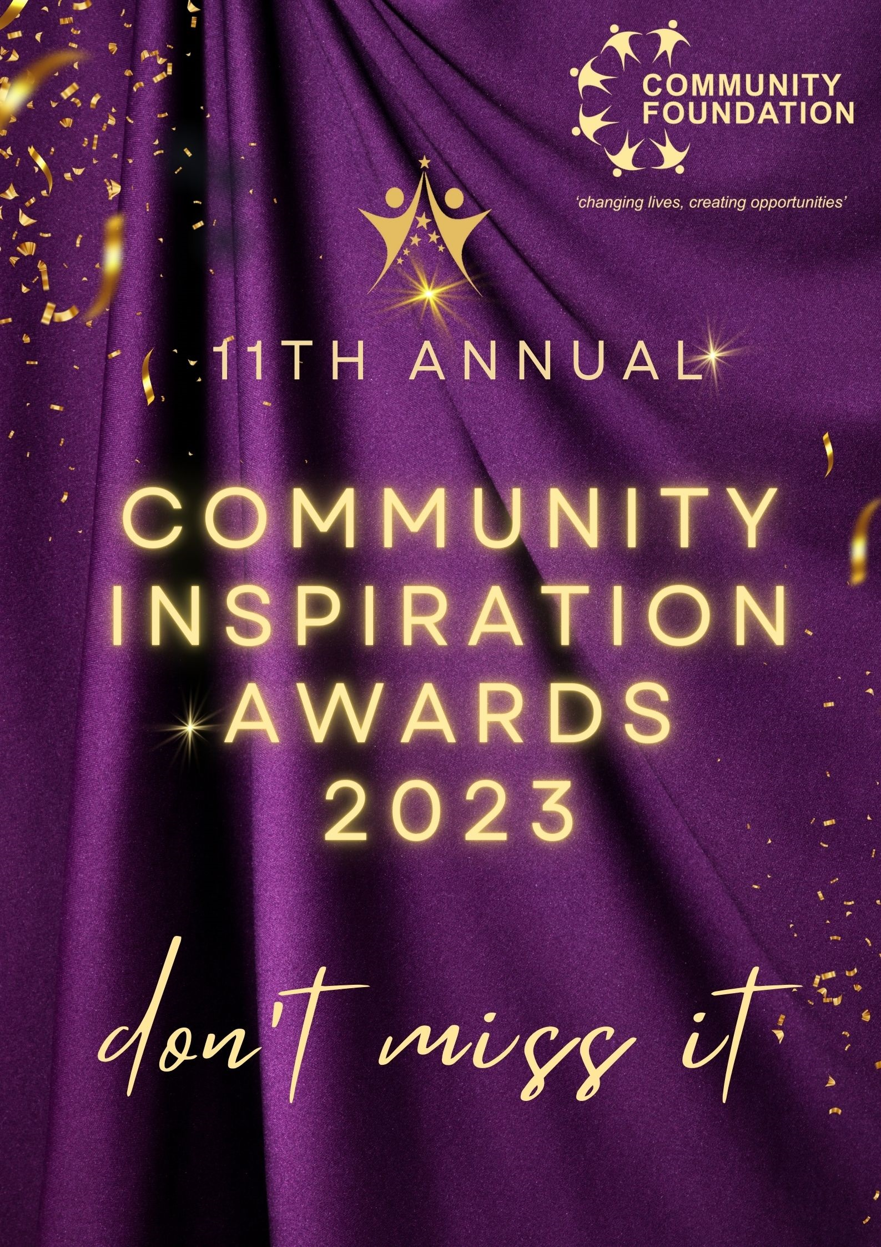
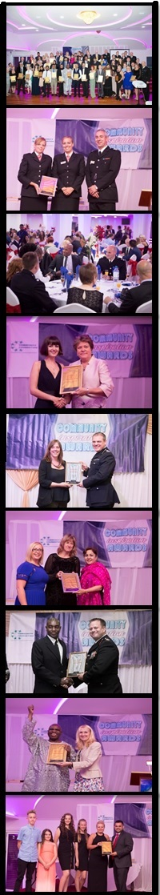
11th Community Inspiration Awards 2023
Sponsorship Opportunity

The annual Community Inspiration Awards is organised by the Community Foundation, to recognise outstanding contributions made by staff from public sector organisations, charities, businesses and members of the community, whose efforts have made a positive difference in the community and has inspired and motivated others.
The awards ceremony is an invite-only event, scheduled for Friday 8th September 2023. Our judges will announce the finalists and winners who will receive one of the awards from distinguished invited dignitaries, including Members of Parliament, Council Leaders and chief officers from public sector bodies. Our chief guest this year is Andy Street- Mayor of West Midlands.

By sponsoring the Community Inspiration Awards, your organisation will make a significant difference in helping to recognise the outstanding achievements made by the people and organisations, whose efforts have made a positive difference in the community and has inspired and motivated others. These contributions often go unnoticed and are not publicly mentioned or celebrated. Through your support, we can make sure recognition is given to these selfless individuals.

We have a range of sponsorship packages available which offer sponsors a variety of branding opportunities throughout the event promotional schedule as well as in the awards brochure, on the website and at the event itself.

Sponsorship opportunities are available for organisation/companies to sponsor an award. There are 15 award categories in this year’s event. You can sponsor as many awards as you want and can select the award category which most closely represents your organisation. Award sponsors will benefit from the extensive publicity that will be generated before, during and after the event.

Previous sponsors and supporters include:

WM Combined Authority WM Police WM Fire Service
Birmingham City Council Coventry City Council Dudley City Council Worcester City Council Sandwell Council Walsall Council
Solihull Council Canal and River Trust Aston University
Longhurst Group Victoria Property Services MIAPI
BC Metals Trading Ltd AV2RENT SND Electricals
University of Birmingham South and City College BMet College
Greater Birmingham Chamber of Commerce Liberal International
Birmingham Community Healthcare Trust NHS Birmingham and Solihull ICS

We have three sponsorship categories:

1. Gold Sponsorship (sponsorship fee £500)

- Sponsor of one award
- Sponsor name and logo added to website and all other marketing and promotional items as “Gold Sponsor of the Community Inspiration Awards”
- Sponsor logo will be displayed on the stage screen at the opening of the ceremony
- VIP tickets and table reservation for 2 people

. 2. Platinum Sponsorship (sponsorship fee £1,500)

- Sponsor of two awards
- Sponsor name and logo added to website and all other marketing and promotional items as “Platinum Sponsor of the Community Inspiration Awards”
- Sponsor logo will be displayed on the stage screen at the opening of the award ceremony
- Sponsor name and Logo added to the Award Ceremony Event Programme as “Platinum Sponsor of the Community Inspiration Awards”
- Sponsor name will be mentioned when the names of the finalist for the award are read out at the Awards Ceremony
- Sponsor name will be mentioned at the opening of the Awards Ceremony as “Platinum Sponsor of the Community Inspiration Awards”
- VIP tickets and table reservation for 4 people

3. Diamond Sponsorship (sponsorship fee £5,000)

- Sponsor of three awards
- Sponsor name and logo added to website and all other marketing and promotional items as “Diamond Sponsor of the Community Inspiration Awards”
- Sponsor logo will be displayed on the stage screen at the opening of the award ceremony
- Sponsor name and Logo added to the Award Ceremony Event Programme as “Diamond Sponsor of the Community Inspiration Awards”
- Sponsor name will be mentioned when the names of the finalist for the award are read out at the Awards Ceremony
- Sponsor name will be mentioned at the opening of the Awards Ceremony as “Diamond Sponsor of the Community Inspiration Awards”
- VIP tickets and complete table reservation for 10 people
- A representative from your organisation will be given the privilege to come on stage to give an award
- Photo opportunity with all award winners and the Judges at the Community Inspiration Awards Ceremony
- Framed Certificate of Appreciation presented on stage
- Your organisation will be introduced with the following sponsorship title at the ceremony: “The Community Foundation presents the Community Inspiration Awards 2023 in association with (your organisation name)”
- Logo placement on front cover of the official Community Inspiration
Awards Ceremony Programme as the sponsorship title: “Community Inspiration Awards in association with (your organisation name)
- One person from your organisation will have a seat on the same table as the West Midlands Mayor- Andy Street.

COMMUNITY INSPIRATION AWARDS 2023 SPONSORSHIP FORM

Full Name:
Job Title:
Organisation/
Company
Address &
Post Code:
Tel:
Email:

Our organisation/company would like to sponsor the Community Inspiration
Awards 2023. (Please tick the sponsorship you would like to take)

1 | Gold Sponsorship (£500)
2 | Platinum Sponsorship (£1500)
3 | Diamond Sponsorship (£5000)

Please email the completed application to: info@thecommunityfoundation.org.uk

To post: Community Foundation, Quayside Tower, 11th Floor, 252 – 260 Broad Street,
Birmingham, B1 2HF

For cheque payment: Please make payable to: Community Foundation
(Please write your company name on the back)

For direct bank transfer:
Lloyds Bank
Sort Code 30-97-77
Account No. 14291560
(Please write your company name as the reference)

For further information, please contact: Medina Mulla:
Tel: 0121 643 6490 or email: medina@thecommunityfoundation.org.uk
www.thecommunityfoundation.org.uk | www.facebook.com/communityfoundationuk

